**KEY PERSONNEL**

***“Virtual Pitch Day”* QUICK REFERENCE GUIDE**

**THE PROCESS**

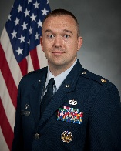

45th Contracting Squadron Commander

**Lt Col Jason Holman**

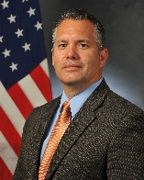

Director of Business Operations

**Marco Mendez**

**Superintendent**

MSgt Anthony Parsons

**45 Contracting Squadron Pitch Day Team**

2nd Lt Adam Grant Oren Gilbert

Gina Russell Mark Carey

**ADDITIONAL INFORMATION**

**Email**

[45CONS.PK.PitchDay@us.af.mil](mailto:45CONS.PK.PitchDay@us.af.mil)

**Link**

<https://beta.sam.gov> Search: CSO Patrick SFB

*This brochure is for informational purposes only.

Please use the above link for current documents.*

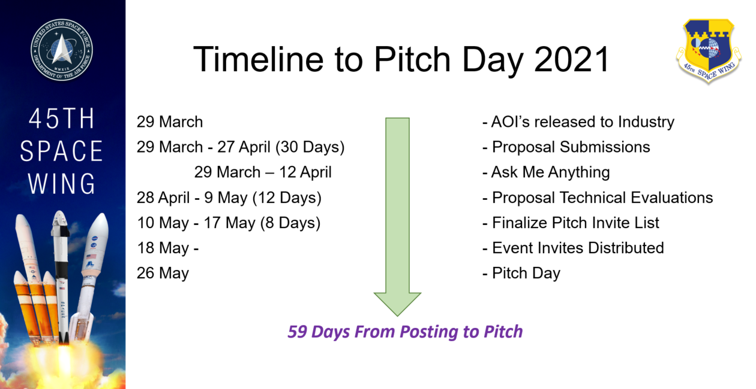

The Eastern Range (45th Space Wing) and Western Range (30th Space Wing) are offering a commercial solutions opening authorized by Section 879 of the National Defense Authorization Act for Fiscal Year 2017 (Pub. L. 114-328). Under a CSO, the USSF may competitively award contracts to proposals received in response to a general solicitation, similar to a broad agency announcement (BAA), to acquire innovative commercial items, technologies, and services, based on a review of proposals by scientific, technological, or other subject-matter expert peers within the USSF. Under this CSO, all items, technologies, and services shall be treated as commercial items.

**45th Contracting Squadron**



**Patrick Space Force Base, FL**

**45th Space Wing’s   
Commercial Solutions Opening**

***Virtual* Pitch Day**

**May 26, 2021**

“Acquiring innovative solutions that address the United States Space Force’s

Commitment to Deliver

100% Mission Success, Shape the Future and Invest in our People.”

**45 SW Areas of Interest**

**TITLE: Space Operations Support**

**DESCRIPTION:** The 45th Space Wing is a team of mission-ready warriors and professionals delivering assured access to space for warfighters and our Nation through the Eastern Space Launch Range and two Airfields. Space operations support areas of interest include weather, business systems & information technology that facilitate space lift mission success. The Space Force wishes to stay at the cutting edge of these various functions and technologies and is looking to partner with innovative small businesses that may have solutions to Space Force Areas of Interest (AOIs). The Problem Statements listed below are high level AOIs for Patrick Space Force Base for a Pitch Day that will occur on***: 26 May 2021***

**1. Need:** Automated personnel scheduling tool. Personnel scheduling tool which can automate the scheduling process while taking into account: training, certifications, proficiency tests, crew rest, leave, quantity of missions by role, etc. System should also monitor expiring training, certifications, etc., to ensure all personnel are up to date with mission proficiency requirements.

**2. Need:** Streamline/Increase collaboration capability. Something to increase capability over OneNote or physical paper for collaborative checklists and coordination. 10+ users simultaneously editing documents and updating in near real time. Additionally, semi-automated reporting that allows the entrance of data in one location that will auto populate into multiple separate reports for different audiences and purposes.

**3. Need:** Augmented reality capability to support mission assurance objectives. Give operator access to regulations, technical specifications, and nominal data readings in conjunction with viewing a launch vehicle.

**4. Need:** Provide an automated, computer based training platform to allow members to gain and maintain positional proficiency on locally developed training with the ability for units to author and edit training packages to meet changing mission needs.

**5. Need:** Semi-automated/virtual assessments of processes and/or systems. Without being a simulation expert, provide user with the ability to virtually model processes and/or systems and implement system changes for evaluation and assessment. Additionally, provide auto-generation of change requests for system and/or process updates. Potential use-cases: cyber security assessments of system changes, launch range scheduling processes, etc.

**6. Need:** Big Data aggregation and analytic capability. Big data analytical capability focused on locally collected weather data with a focus on descriptive and diagnostic analytics. Possible expansion into predictive and presumptive weather analytics.

**7. Need:** Allow weather operators to simultaneously display and manipulate multiple formats of local meteorological observation/system health information from separate, physical, non-networked, real-time data streams in a Common Operating Picture display.

**TITLE: Installation Support**

**DESCRIPTION:** The 45th Space Wing is a team of mission-ready warriors and professionals delivering assured access to space for warfighters and our Nation through the Eastern Space Launch Range and two Airfields. Space operations support areas of interest include weather, business systems & information technology that facilitate space lift mission success. The Space Force wishes to stay at the cutting edge of these various functions and technologies and is looking to partner with innovative small businesses that may have solutions to Space Force Areas of Interest (AOIs). The Problem Statements listed below are high level AOIs for Patrick Space Force Base for a Pitch Day that will occur on***: 26 May 2021***

**1. Need:** Real-time tracking of vehicles and equipment on Cape Canaveral Space Force Station & Kennedy Space Center (141,325 acres) while also allowing for usability amongst all stakeholders. The solution should also provide a planning/ forecasting feature to allow for the de-conflicting of movement during scheduled launch times.

**2. Need:** A program that can intake multiple data sources and provide a real-time outlook that could enable the ability to monitor all operations taking place at CCSFS.

**3. Need:** A solution is requested to enable the transfer of real property documents to an online database, with both uploading and downloading capabilities, in conjunction with a lower bandwidth network.

**4. Need:** A mobile device solution that integrates with the current inventory system allowing for combining photos and inventory reports into one file and enabling the capability to transfer this document onto a government database.

**5. Need:** High-performance software, government and commercial network, workstations, additive and subtractive manufacturing capabilities using innovative technologies/materials in order to establish an Innovation Lab for either space launch/range operations or installation/personnel management

**6. Need:** An automated customer entry system that allows for both contact tracing and customer vetting with the capability to audibly and visually indicate rather entry is permitted for specific ID cards after scanning. The system would also log the arrival and departure times; this data would be

**TITLE: Broad Innovation Support**

The Space Force is interested in exploring innovative technology domains that may not be covered in the lists above, so this topic is intended to also be a call for open ideas and technologies that cover other related areas not currently listed (i.e. the unknown-unknown). This topic is meant for innovative solutions to be adapted in innovative ways to meet Space Force stakeholders’ needs in a short timeframe and at a low cost.

