Space Launch Delta 45 Hazard Area

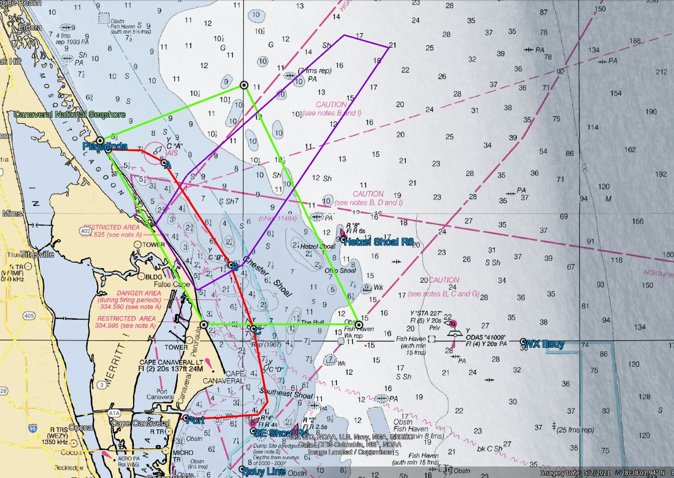

**SPACEX INSPIRATION-4**

**15 Sep 21**

LAUNCH HAZARD AREA COORDINATES

(PURPLE BOX ON MAP)

2839N  8037W

2843N  8035W

2854N  8021W

2853N  8017W

2836N  8030W

2834N  8034W

2834N  8034W

2839N  8037W

Please remain clear of the

**Launch Hazard Area from:**

**6 PM – 1:45 AM**

If launch is delayed the next attempt will be

**16 Sep 21**.

Backup Launch Hazard Area Times:

**Will be the same**

Launch Information Recorded Line:

1-800-470-7232

Coast Guard safety zone A active 15 Sep/7:17PM. – 16 Sep/1:36 AM.

**Detailed Launch Area Information can be obtained using Coast Guard channel 16 or FM81A and Notice to Mariners @** [**http://www.navcen.uscg.gov/?pageName=lnmDistrict&region=7**](http://www.navcen.uscg.gov/?pageName=lnmDistrict&region=7)

Coast Guard security zone active 6:02 pm – LAUNCH. Contact Coast Guard on CH 16.

Approx. 33 miles from Port Canaveral.