45th Space Wing Launch Hazard Area

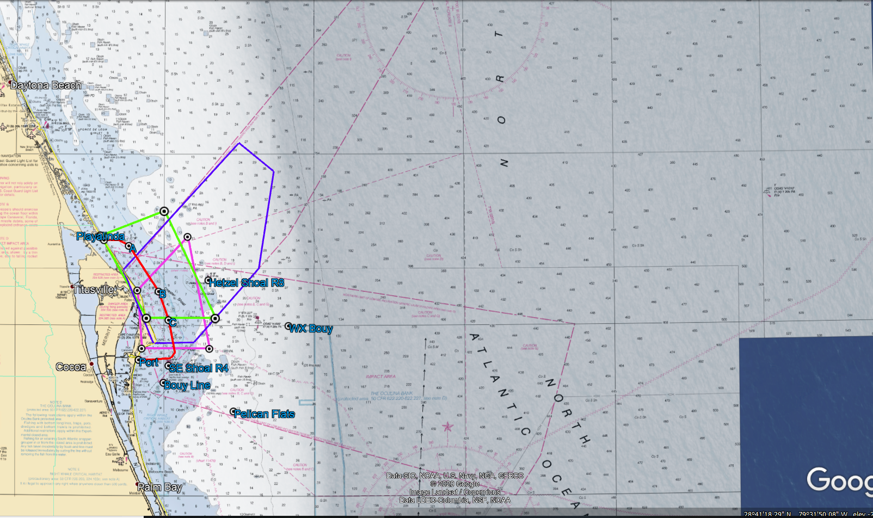
Coast Guard safety zone A and C active 8:15 AM – 12:15 PM.

Approx. 41 miles

Coast Guard security zone active 7:00 AM – LAUNCH. Contact Coast Guard on CH 16.

Please remain clear of the
Launch Hazard Area from:
7:00 AM – 1:00 PM
If launch is delayed the next attempt will be 18-Dec-20.
Backup Launch Hazard Area: 7:00 AM - 1:00 PM
Launch Information Recorded Line:
1-800-470-7232

FALCON 9 NROL-108

17-Dec-20

LAUNCH HAZARD AREA COORDINATES

(PURPLE BOX ON MAP)

28 39 43.36N 80 38 11.63W
29 02 0.00N 80 15 0.00W
28 57 0.00N 80 08 0.00W
28 40 0.00N 80 11 0.00W
28 27 0.00N 80 24 0.00W
28 26 51.52N 80 32 7.11W

Detailed Launch Area Information can be obtained using Coast Guard channel 16 or FM81A and Notice to Mariners @ http://www.navcen.uscg.gov/?pageName=lnmDistrict&region=7

