45th Space Wing Launch Hazard Area

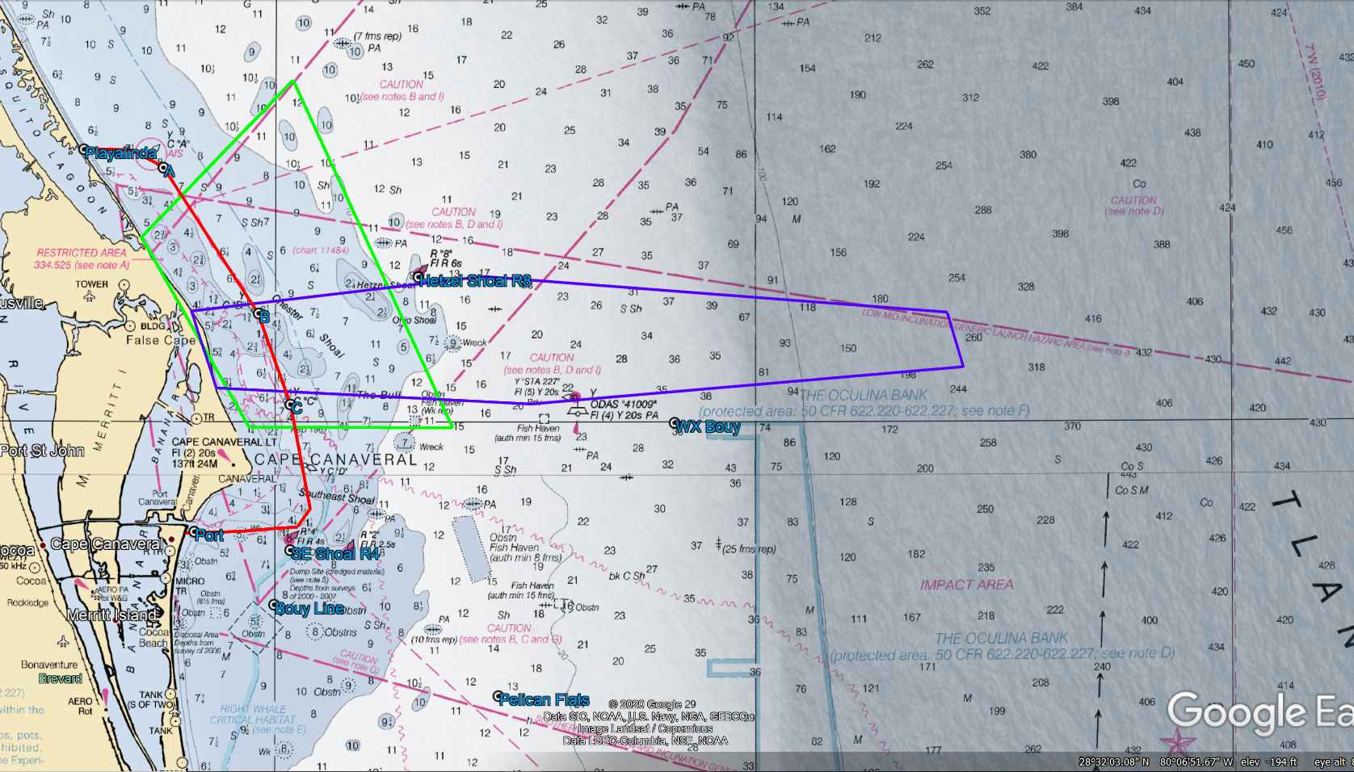
Coast Guard safety zone B active 7:43 PM – 8/12:43 AM.

Approx. 44 miles

Coast Guard security zone active 6:28 PM – LAUNCH. Contact Coast Guard on CH 16.

Please remain clear of the
Launch Hazard Area from:
6:15 PM – 8/1:15 AM
If launch is delayed the next attempt will be 8-Jan-21.
Backup Launch Hazard Area: 6:15 PM – 9/1:15 AM
Launch Information Recorded Line:
1-800-470-7232

FALCON 9 TURKSAT-5A

7-Jan-21

LAUNCH HAZARD AREA COORDINATES

(PURPLE BOX ON MAP)
28 36 4.77N 80 35 15.31W
28 38 0.00N 80 17 0.00W
28 36 0.00N 79 48 0.00W
28 33 0.00N 79 47 0.00W
28 31 0.00N 80 14 0.00W
28 31 51.59N 80 33 40.89W

Detailed Launch Area Information can be obtained using Coast Guard channel 16 or FM81A and Notice to Mariners @ http://www.navcen.uscg.gov/?pageName=lnmDistrict&region=7

